## Cnvlutin: Ineffectual-Neuron-Free Deep Neural Network Computing

### Corresponding author

Jorge Albericio, University of Toronto

Andreas Moshovos, University of Toronto

### Keywords

Neural Network; Accelerator; Dynamic sparsity

### Summary

#### Challenge

A large fraction of the computations performed by Deep Neural Networks (DNNs) are intrinsically ineffectual as they involve a multiplication where one of the inputs is zero.

#### Contribution

*Cnvlutin* (CNV), a value-based approach to hardware acceleration that eliminates most of these ineffectual operations, is designed to improve performance and energy over a state-of-the-art accelerator with no accuracy loss. CNV uses hierarchical data-parallel units, allowing groups of lanes to proceed mostly independently enabling them to **skip over zero-valued operand multiplications.**

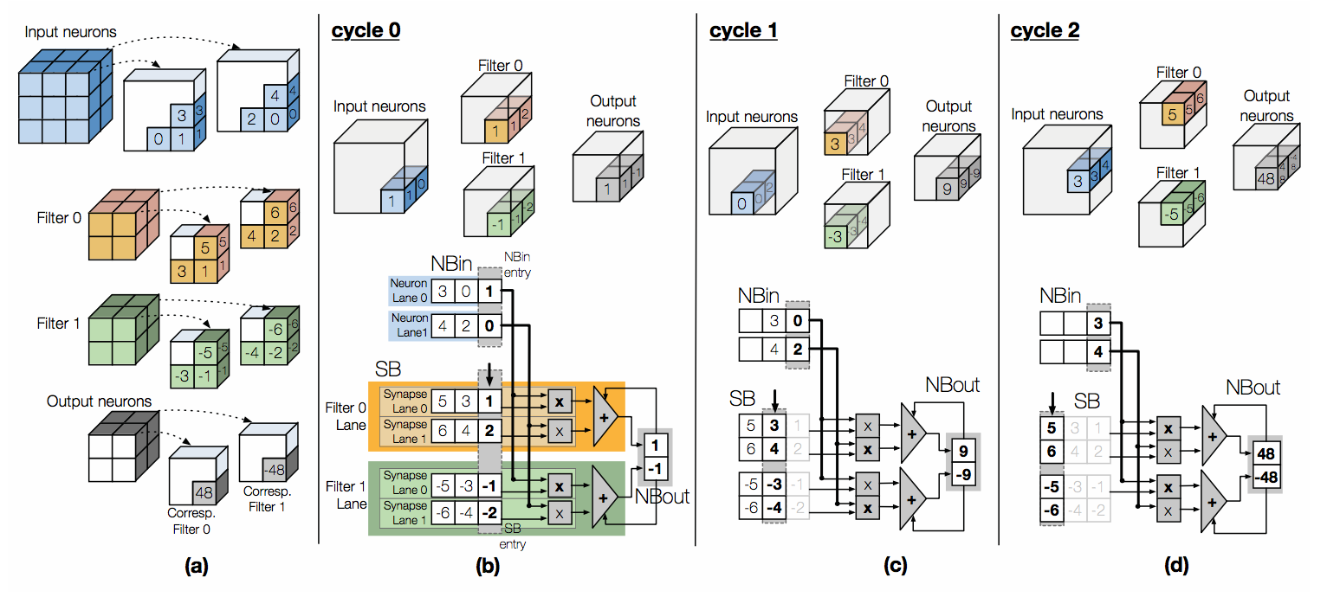

For a typical simplified state-of-the-art DNN unit Example, the calculation of the complete filter would four cycles in all, only the first three cycles are shown here for simplicity. Cycle 0: the first two neurons from NBin (1 and 0), are multiplied with the respective synapses of the two filters, ((1,2) and (-1,-2)), each product pair per filter is reduced through the adder and stored in NBout (1 and -1). The SB pointer advances by one and the neuron is discarded from NBin. Cycles 1 and 2: The same sequence of actions for the next input neuron and filter synapse pairs. The NBout partial sums are read and used as extra inputs to the adder tree making progress toward calculating the final output neurons.

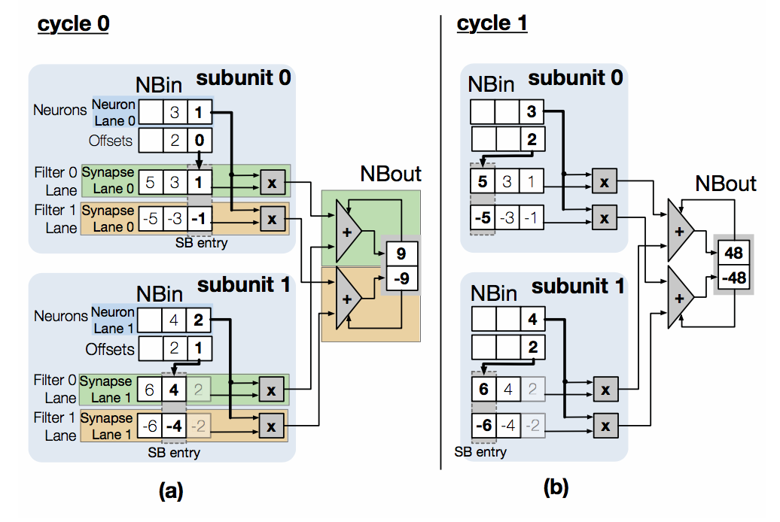

However the proposed CNV unit produces the same output as shown in the above figure in just two cycles. The elements of both filters have the same values with opposite signs only for the sake of clarity. Cycle 0: Subunit 0 reads the next NB neuron value 1 and its offset 0. Using the offset it indexes the appropriate SB synapses 1 and -1 corresponding to filter 0 and 1. The resulting products 1 and -1 are added to output neurons for the corresponding filters using the dedicated adder trees. Similarly subunit 1 will fetch neuron 2 with offset 1 and multiply with synapses 4 and -4 feeding the corresponding adder trees for the filters. Cycle 1: The operation repeats as before with subunit 0 fetching neuron 3 at offset 2 and subunit 1 fetching neuron 4 at offset 2. The same result as in the baseline (48, -48) is calculated in only two cycles.

#### Result

By doing so, this method can both reduce the use of computing resources and speed up memory accesses, thereby optimizing performance and energy consumption. Experiments show that CNV improves performance over a state-of-the-art accelerator from 1.24× to 1.55× and by 1.37× on average without any loss in accuracy by removing zero-valued operand multiplications alone. It improves overall EDP (Energy Delay Product) and ED2P (Energy Delay Squared Product) on average by 1.47× and 2.01× respectively with an area overhead of 4.49%.